General EWIS Installation

Signal and Endpoint Classification

Particular Risks
FE-INST-0001 Particular risk events
Particular risks events are caused by an individual failure mode (for example an uncontained engine rotor failure) or external event (for example a bird strike) that could potentially eliminate all three (3) EWIS channels and therefore causing a catastrophic failure condition (e.g. loss of deceleration capabilities, loss of fuel, loss of all flight instruments, etc.).
EWIS channels shall be separated in the aircraft to ensure that at least one (1) EWIS channel is not impacted by a particular risk event. This is the update text of the requirement
Particular risk events that must be considered for EWIS channel separation are listed in Table 1, and are an essential part of a certifiable and safe EWIS design.

Table 1 - PARTICULAR RISK EVENT OVERVIEW
Particular Risk Events | Certification Reference | Threat Zone, 3D-Model Number
Uncontained Rotor Failure | 18 CFR 32.20 | <TBD>
Wheel and Tire Failure | EASA CS 32.586 | <TBD>
Bird Strike x2 | 19 CFR 32.482 | <TBD>

FE-INST-0002 Particular risk analysis
Only single particular risk events need to be addressed. Multiple particular risk events need not be addressed (ref. 18 CFR 32.20). The analysis of these events and resulting EWIS failures, and in combination with other aircraft system failures, are the responsibility of the Aerion System Safety group. The requirements in sections 3.2.1 to 3.2.2 are in this standard to support the designer in creating an EWIS design that accounts for the particular risk events.

Uncontained Engine Rotor Failure (UERF)
FE-INST-0003 Uncontained engine rotor failure
Service experience shows that uncontained engine rotor failures have occurred resulting in the release of high velocity rotor fragments or other engine component fragments. These fragments have impacted and damaged critical aircraft structures, fuel tanks, systems, controls, and other engines on the aircraft, as well as caused serious or fatal injuries to passengers and crewmembers.
To prevent an UERF we follow internal directive FEID-0024-3.

Birdstrike
FE-INST-0004 Bird strike
No bird impact should result in a hazardous or catastrophic loss of system equipment. For a bird strike scenario adequate aircraft functionality must be maintained to ensure continued safe flight and landing without exceptional flight crew skill. The ability of the system design to sustain damage from a bird strike, and complete the flight safely shall be substantiated by analysis, or similarity, or test, as required.
As far as practicable, EWIS should be installed according FEID-0024-6 This is the update text of the requirement

Aircraft Zone Limitations
FE-INST-0005 Aircraft zones
Aircraft zones are identified together with the different environmental conditions associated to each area, in accordance to the ‘FE Zone Definition and Environmental Condition’ document (ref. FE-2359-761). This supports the selection and installation of all EWIS parts and components and ensures that they can perform their intended function under the environmental conditions of the areas where they are installed. An overview of these aircraft zones and environmental conditions is included in Error! Reference source not found..

General Installation Principles
FE-INST-0006 Harness routing arrangement
Harness routings shall be organized to follow an orderly pre-arranged path such that the harness routings are conveniently visible and accessible for installation, inspection and maintenance.
In general, breakouts should be routed away from structure, to prevent hidden wiring and make the harness routings better accessible as shown in Figure 1. The breakout direction of the bundle however, is also highly dependent on the destination of the bundle and its endpoints.
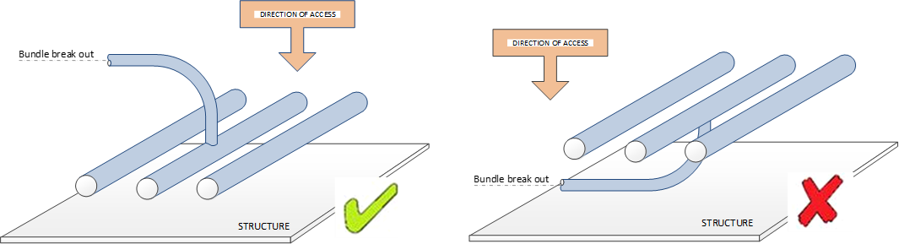

Figure 1 - HARNESS ROUTING ARRANGEMENTS
FE-INST-0007 Harness routing position near ground plane
Harnesses should be routed as close as possible to the ground plane with a maximum clearance of 1.05 inch, without the possibility of damaging the harnesses.

Maintenance Considerations
FE-INST-0008 Use as hand hold or foot rest
EWIS shall be installed so it supports to be used as hand hold or foot rest by maintenance personnel. When this is not possible, a structural barrier is required. This is the update text of the requirement
FE-INST-0009 Accessibility for maintenance and inspection
EWIS shall be installed to provide easy accessibility for maintenance and inspection purposes.

New Column Header 1 | New Column Header 2
Hello update | New sent one
Hello update second | New sent two

